NORTHWIND INTERACTIVE SALES DASHBOARD REPORT

1. INTRODUCTION
The Northwind Interactive Sales Dashboard is a Power BI project created to analyse sales and order information. It shows important details such as total orders, quantity sold, freight charges, product category sales, employee orders and customers by country.
The dashboard uses KPI cards, line charts, bar charts and a product table to present the information clearly. It also includes filters to help users view the data based on different years, regions and product categories.

2. OBJECTIVES
The main objectives of the Northwind Sales Dashboard are:
To analyse total orders and quantity sold.
To display total freight and average freight.
To compare sales across different product categories.
To analyse orders handled by employees.
To identify the number of customers in different countries.
To display product details in a table.
To present important information using charts and KPI cards.
To make the dashboard easy to understand.
To filter the data using year, region and category.

3. DATA TRANSFORMATION USING POWER QUERY
Power Query was used to prepare the Northwind dataset for analysis in Power BI. It helps clean and organise the data before creating charts, tables and KPI cards.

The main activities include:
Checking Data: Checking the available tables and columns.
Changing Data Types: Setting the correct data types for columns
Removing Unnecessary Data: Removing unwanted rows or columns where required.
Renaming Columns: Giving columns suitable names for easy understanding.
Cleaning Data: Checking and correcting missing or incorrect values.
Preparing Data: Organising the required information for sales, products and customers.
Loading Data: Loading the prepared data into Power BI for analysis.

4.MEASURES USED IN POWER BI
DAX measures are used to calculate important values from the Northwind dataset. They help display sales and order information in KPI cards, charts and tables.

Measure | Purpose
Total Orders | Displays the total number of orders.
Total Quantity Sold | Displays the total quantity of products sold.
Total Freight | Displays the total freight charges.
Average Freight | Calculates the average freight charges.
Number of Customers | Displays the number of customers.
Total Sales | Calculates the total sales amount for each product category.

5.KPI CARDS
KPI cards display the important values of the business in a simple format. They help users understand the overall performance quickly.
The dashboard contains the following KPI cards:

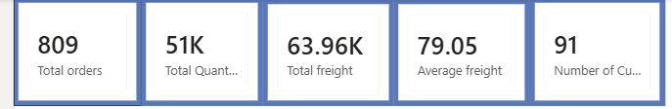
These cards provide a quick summary of orders, product quantities, freight charges and customers.

6. VISUALISATIONS USED

Total Orders by Month
I created a Line Chart to show the total number of orders from January to December. It helps identify months with higher and lower order activity.
Total Sales by Category Name
I created a Column Chart to compare the sales of different product categories. Beverages has the highest sales, followed by Dairy Products.

Total Orders by Employee Name
I created a Bar Chart to compare the total number of orders associated with employees. It helps understand employee-wise order activity.

Number of Customers by Country
I created a Horizontal Bar Chart to show the number of customers in different countries. The USA has the highest number of customers among the countries displayed.

Product-Wise Analysis
I created a Table Visual to display Product Name, Category Name, Total Sales and Total Quantity Sold. It helps compare individual products easily.

KPI Cards
I used Card Visuals to display important values such as Total Orders, Total Quantity Sold, Total Freight, Average Freight and Number of Customers.

Slicers
I used Slicers to filter the dashboard by Year, Region and Category Name. They help users view specific information based on their requirements.

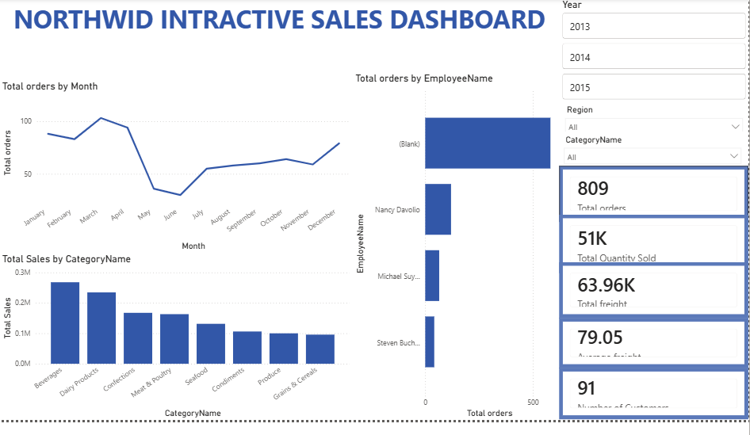

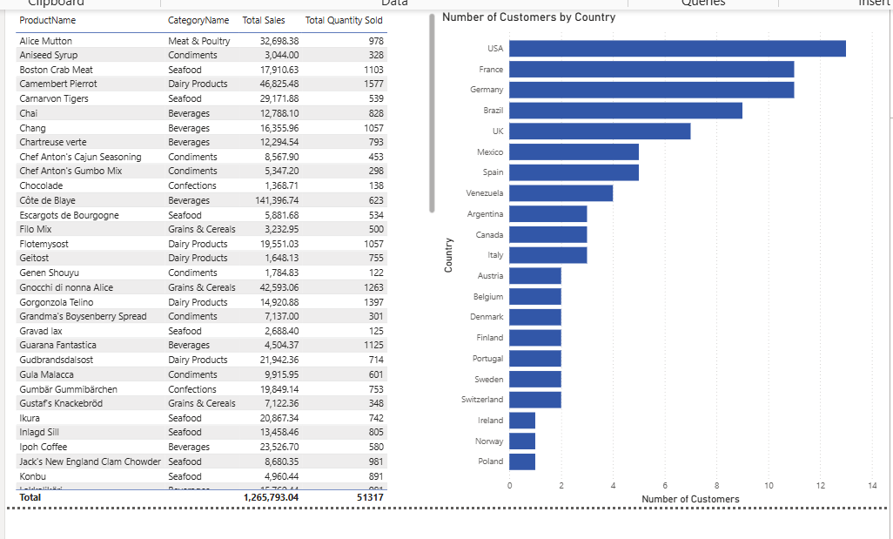

7. CATEGORY NAME STANDARDISATION
Category name standardisation helps maintain consistency in product category names in the Northwind dataset.
The category names were checked to make sure they were displayed correctly and consistently in the dashboard. This helps avoid confusion while analysing different product categories.
Standardised category names are used in:
Category sales chart
Category filters
Product table
Sales analysis
This makes the dashboard more organised and helps users compare sales across different product categories easily.
Note: Include this section as a completed activity only if you actually checked or standardised the category names in Power Query.

8. TOOLTIPS
Tooltips provide extra information when the user moves the cursor over a chart or data point.
The main tooltip details include:
Visualisation | Tooltip Information
Orders by Month | Month and Total Orders
Sales by Category | Category Name and Total Sales
Orders by Employee | Employee Name and Total Orders
Customers by Country | Country and Number of Customers
Product Analysis | Product Name, Total Sales and Quantity Sold
Tooltips help users get additional details without adding too much information to the main dashboard.

SLICERS AND INTERACTIVITY
Slicers are used to filter the data displayed in the dashboard. They allow users to view information based on their requirements.
The dashboard includes the following filters:
Year: To view data for a selected year, such as 2013, 2014 or 2015.
Region: To filter the data by region.
Category Name: To view information for a selected product category.
When a user selects a filter, the related charts and KPI cards can update according to the selection, depending on the visual interactions and relationships set in Power BI.
This feature makes the dashboard interactive and helps users analyse the data from different perspectives.
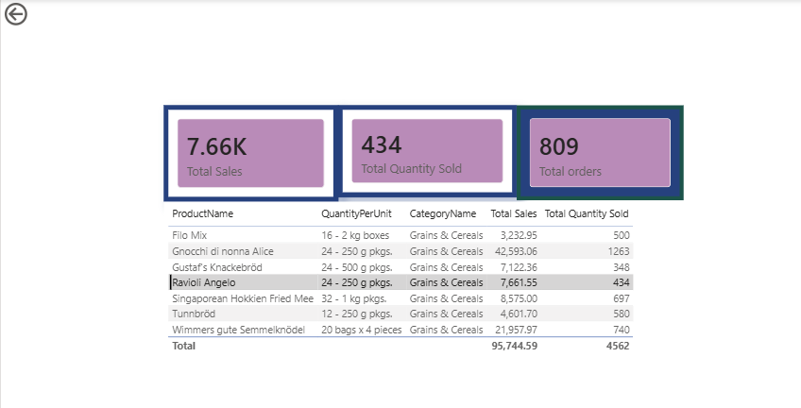

DASHBOARD PAGES
The Northwind Sales Dashboard presents sales information in a single interactive page. It contains KPI cards, charts, a product-wise table, and slicers to analyse the data.
KPI Cards: Display Total Orders, Total Quantity Sold, Total Freight, Average Freight, and Number of Customers.
Monthly Orders Analysis: Shows changes in the number of orders over different months using a line chart.
Category-Wise Sales Analysis: Compares sales across different product categories using a column chart.
Employee-Wise Orders Analysis: Displays the number of orders handled by each employee using a bar chart.
Country-Wise Customer Analysis: Shows the number of customers in different countries.
Product-Wise Details: Displays product information in a table for easy analysis.
Slicers: Allow users to filter the dashboard by Year, Region, and Category Name.
These dashboard elements help users understand sales performance, compare categories, and explore business data easily.

KEY FINDINGS
The dashboard provides the following important findings:
The total number of orders displayed is 809.
The total quantity sold is approximately 51K.
The total freight is approximately 63.96K.
The average freight is 79.05.
The number of customers displayed is 91.
Beverages has the highest sales among the product categories shown.
Dairy Products has the second-highest sales.
Orders are lower during May and June compared with the earlier months shown.
The number of orders increases after June.
The USA has the highest number of customers among the countries displayed.
The employee chart helps compare order activity among employees.
The product table provides details about individual products and their sales.
The filters help users analyse selected years, regions and categories.

8. CONCLUSION
The Northwind Interactive Sales Dashboard provides a clear view of sales, orders, products and customers. It uses KPI cards, charts and a table to present important information in a simple format.
The dashboard helps compare product category sales, understand monthly order trends, analyse employee-wise orders and view customer distribution by country. The filters also make it easier to study the data based on different requirements.
Overall, this project helped me understand how Power BI can be used to present business data through visualisations and make sales information easier to analyse.

